[**4. Junit Spring Test Outputs**](blob:https://github.com/45f9f2b6-4a65-49ff-87f3-7e192cf4f836)

**Exercise 1: Basic Unit Test for a Service Method**

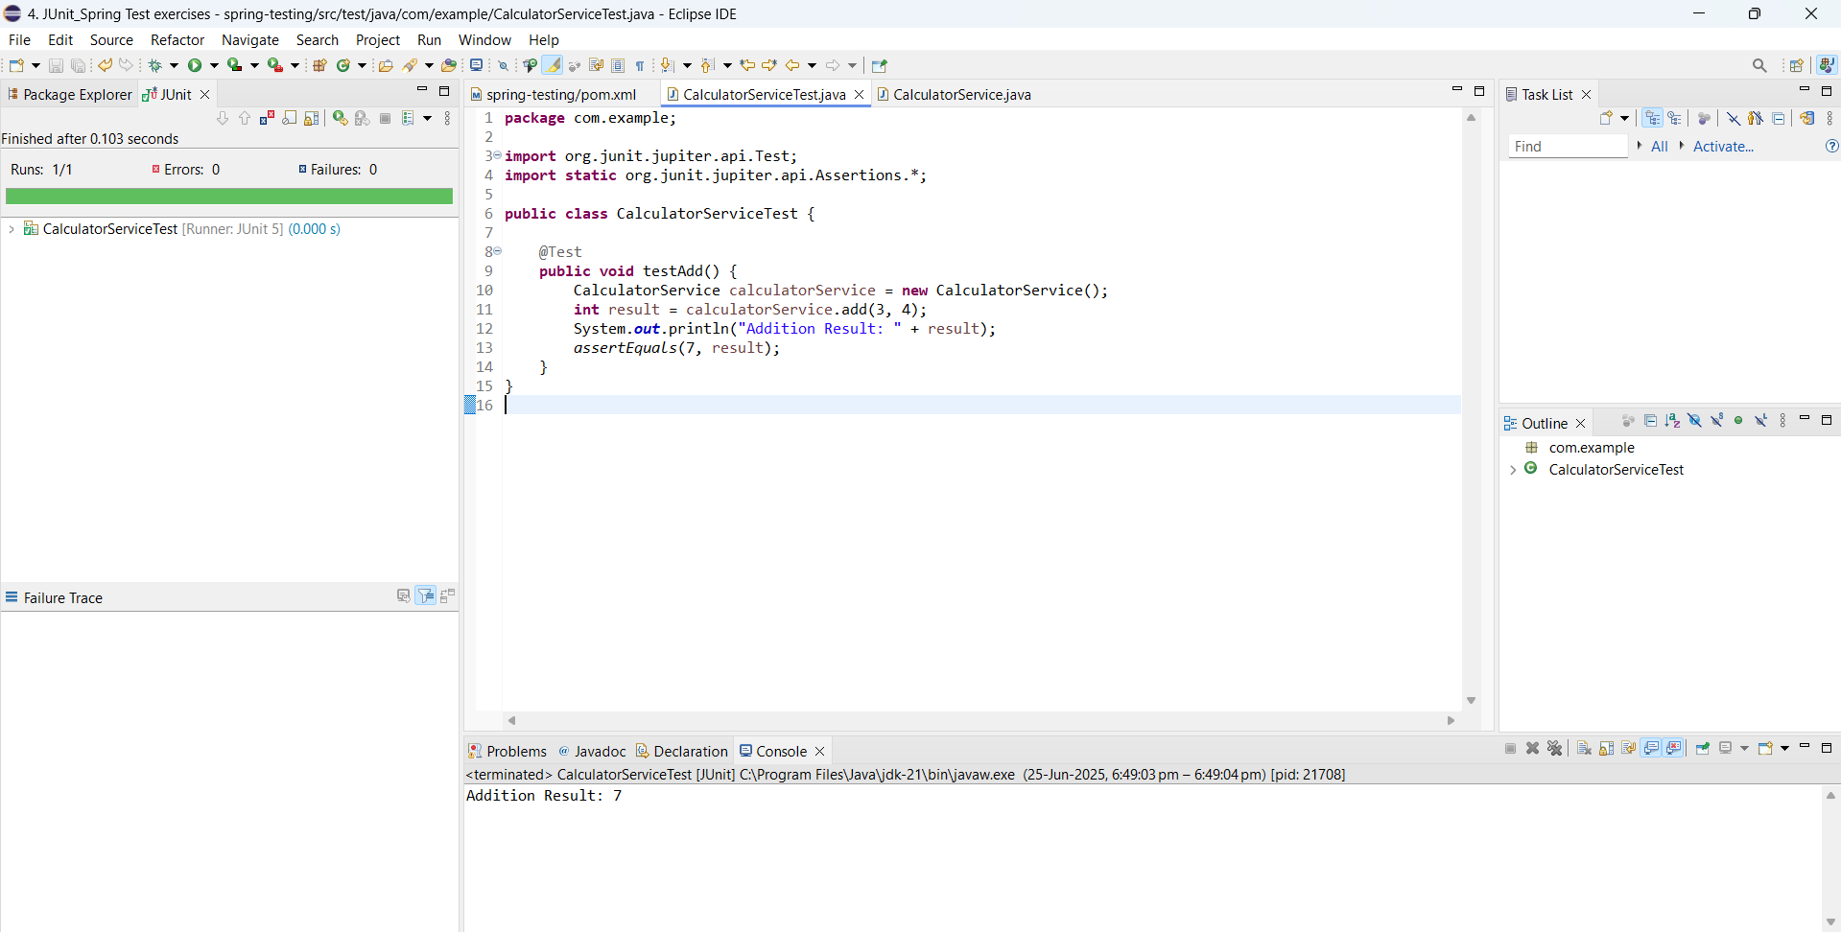

**Exercise 2: Mocking a Repository in a Service Test**

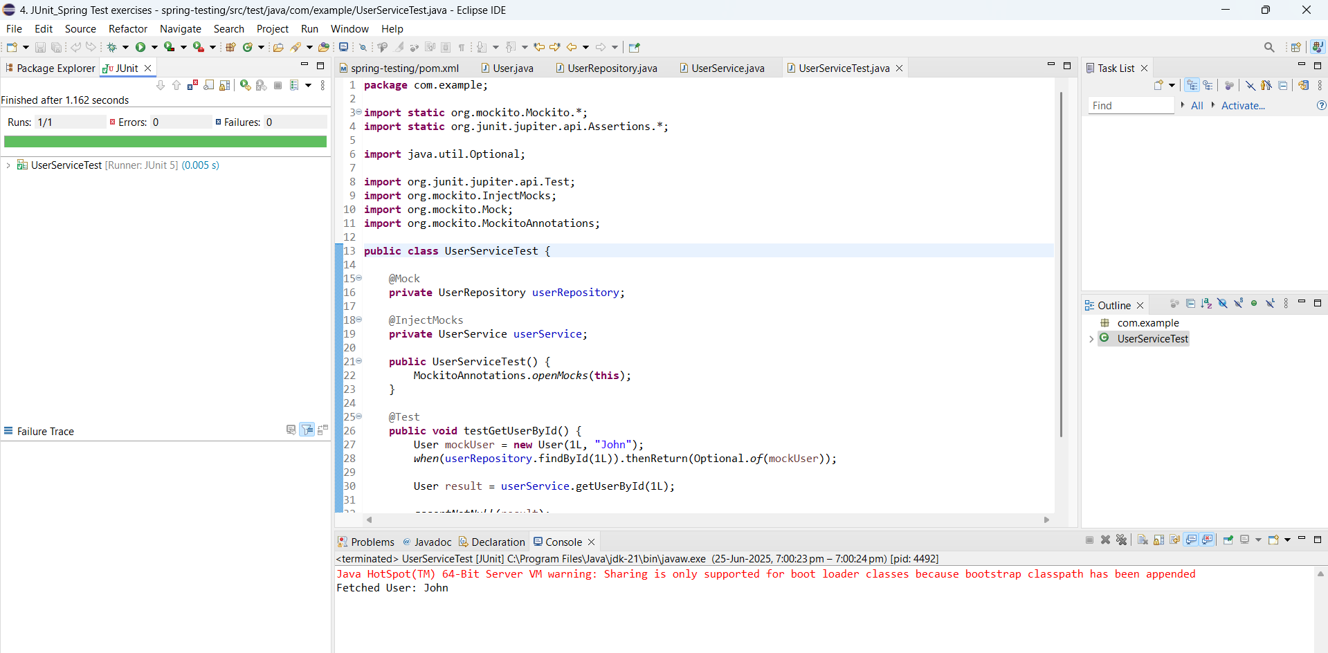

**Exercise 3: Testing a REST Controller with MockMvc**

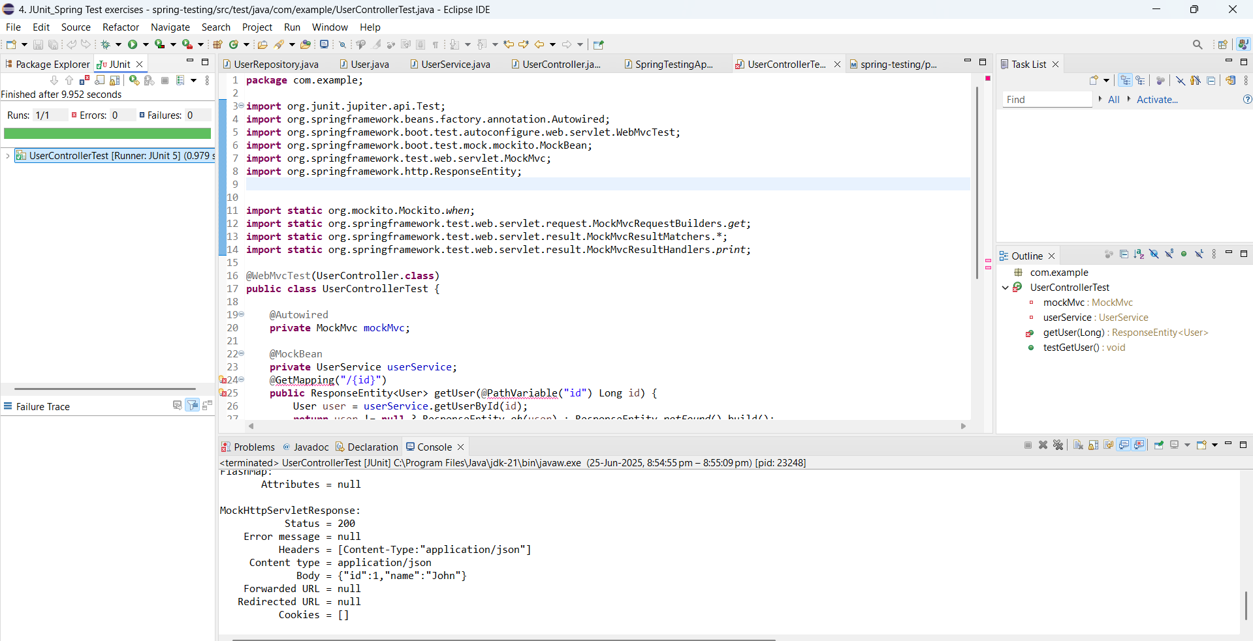

**Exercise 4: Integration Test with Spring Boot**